1. The homepage is displayed with products and the nav bar with home and cart as the navigation.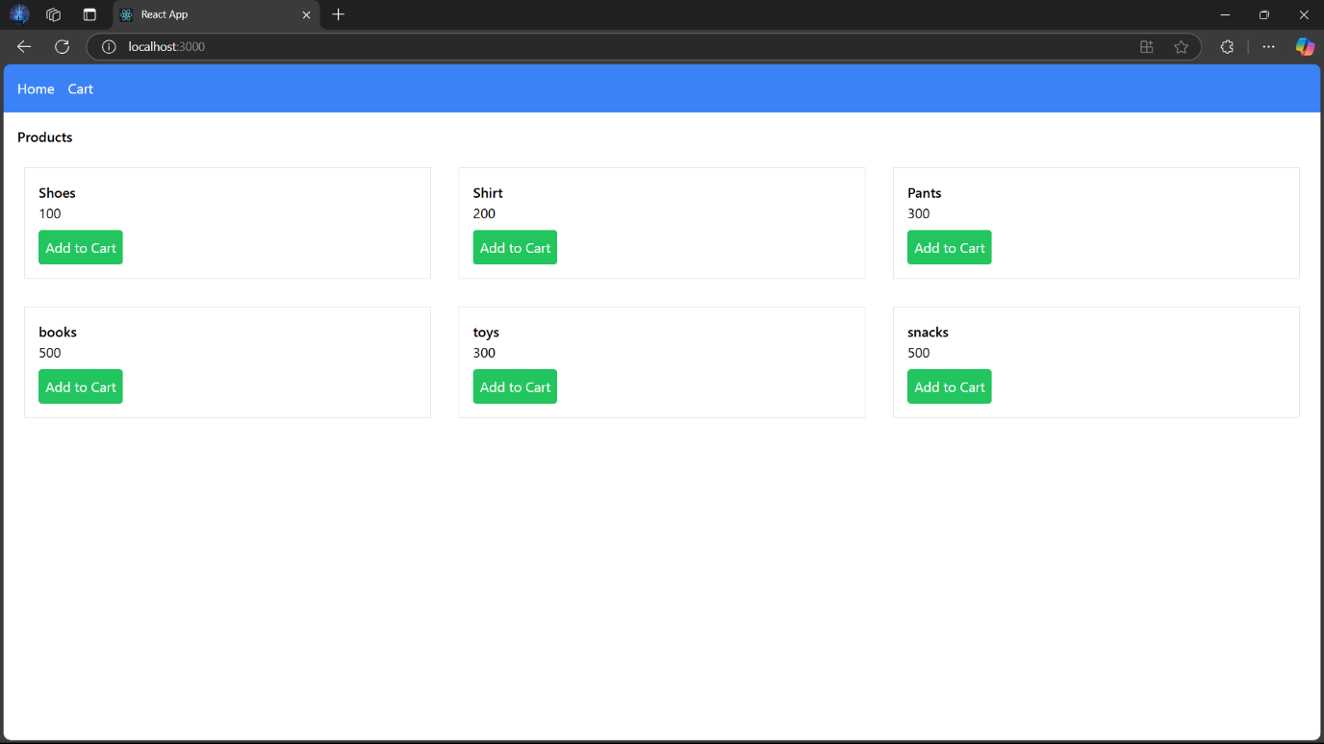
2. Initially the cart page is empty as no products are added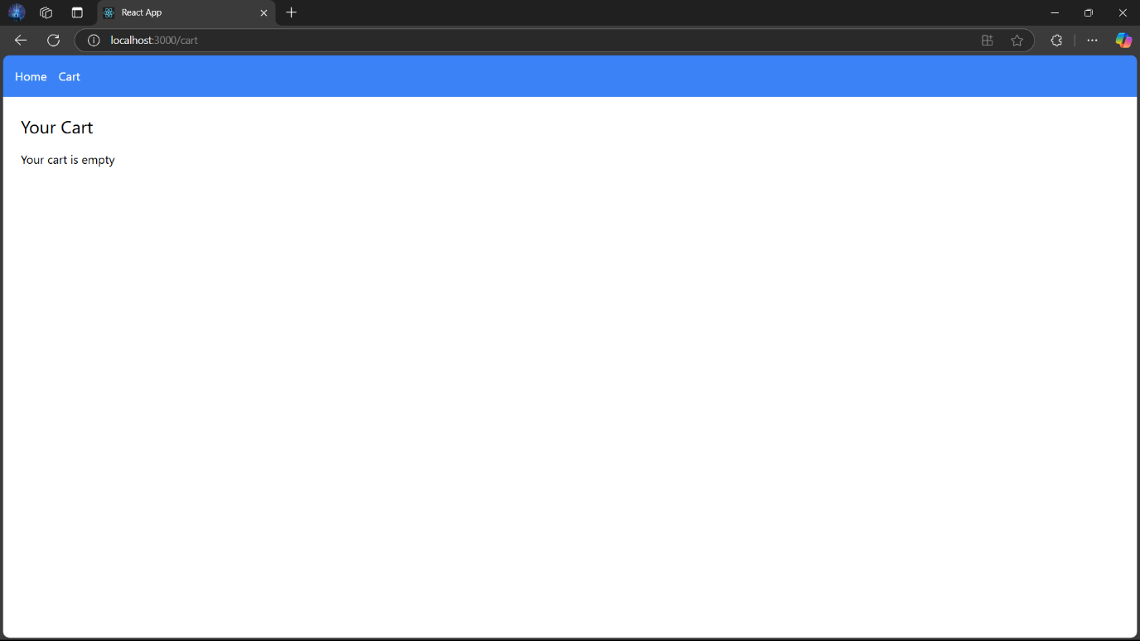
3. Coming back to the home page with the navbar. We can add products.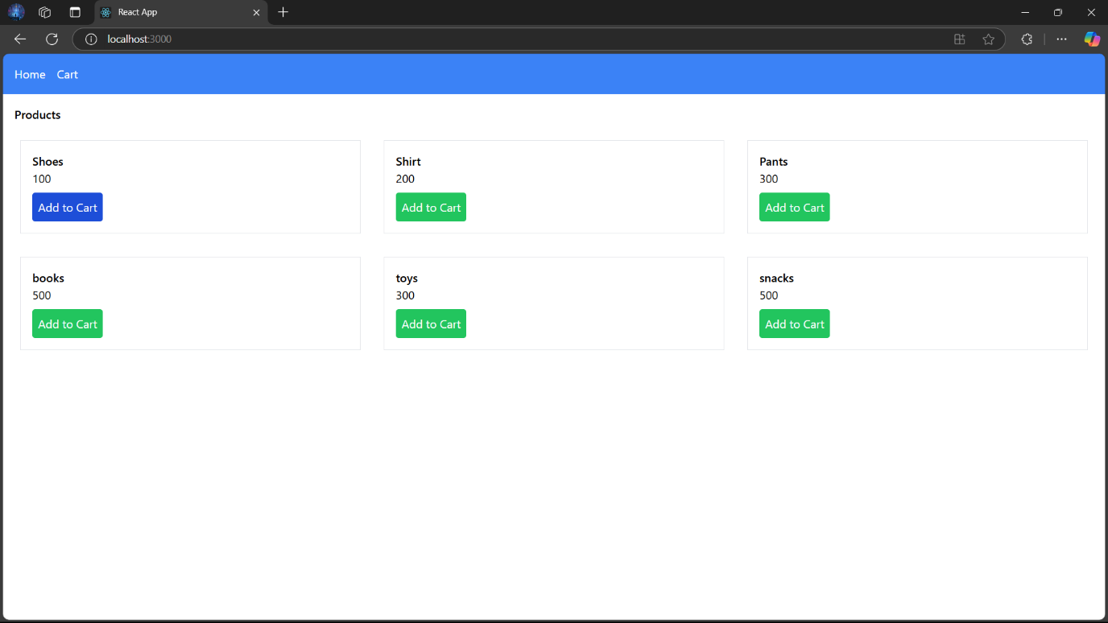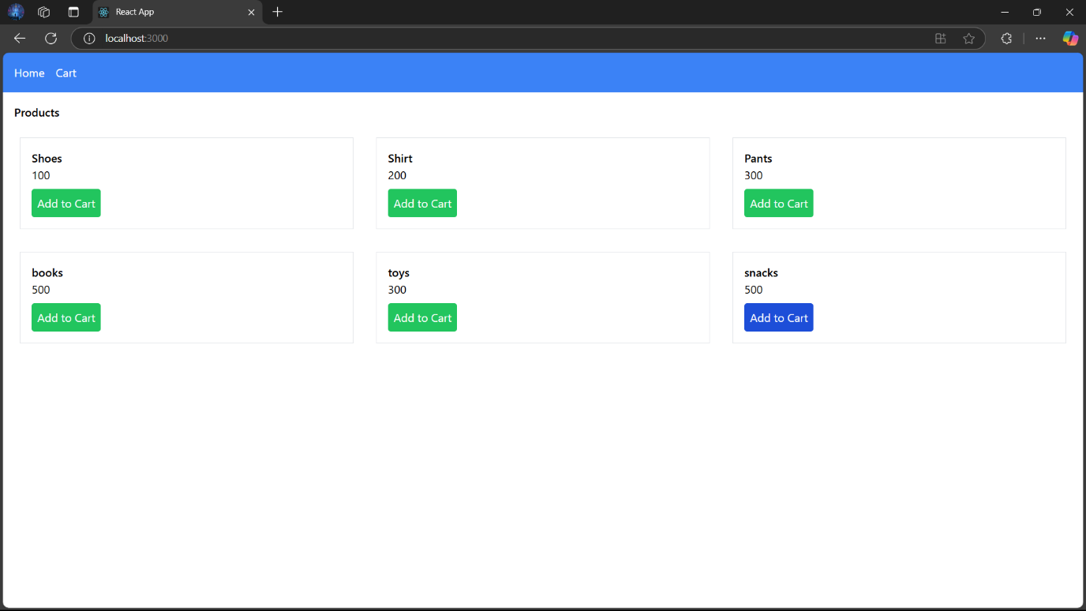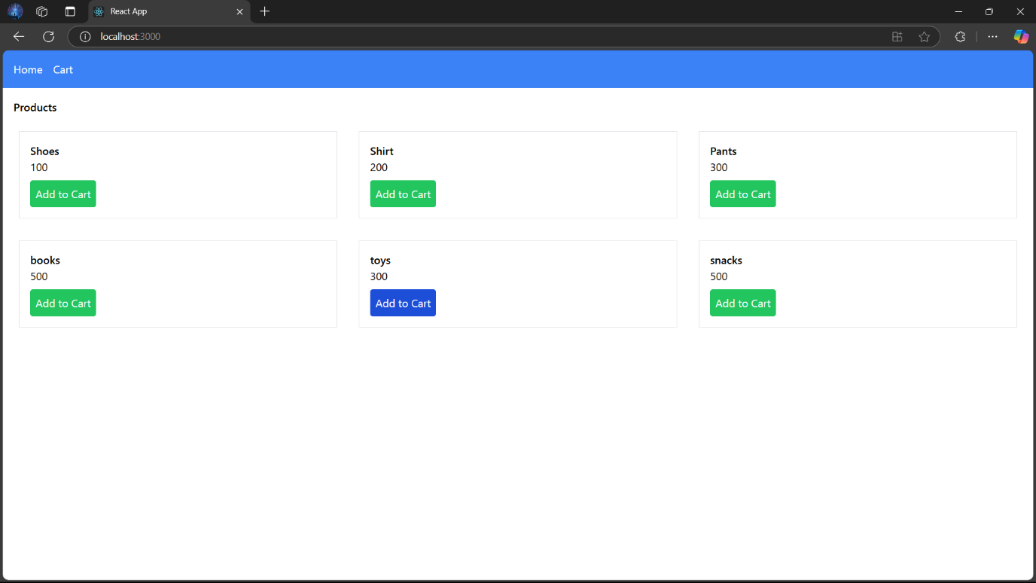
4. 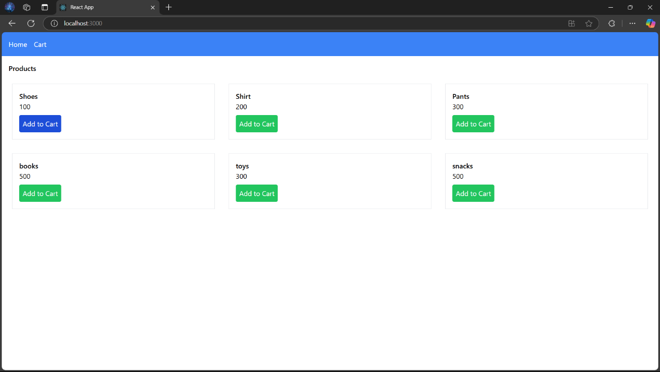Multiple Products can be added into the cart.
5. After adding to the cart, the cart will have the list of items and will have each item’s price and will include the total amount in the cart.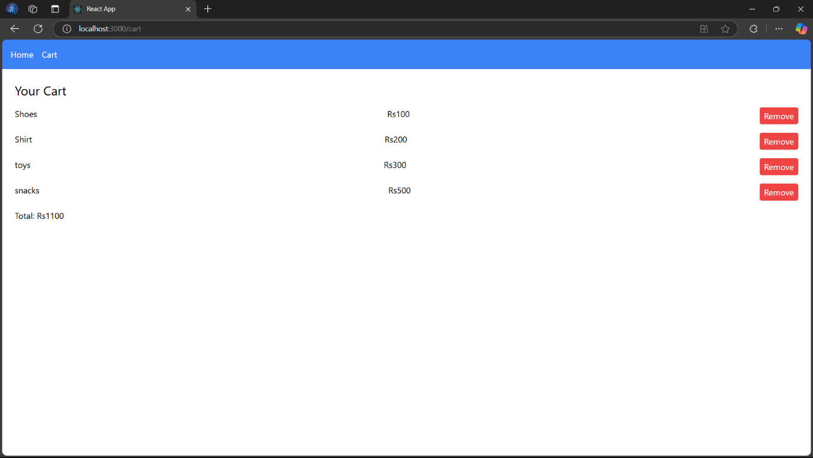
6. The remove button when clicked will remove the respective item present and will reduce the total amount in the cart.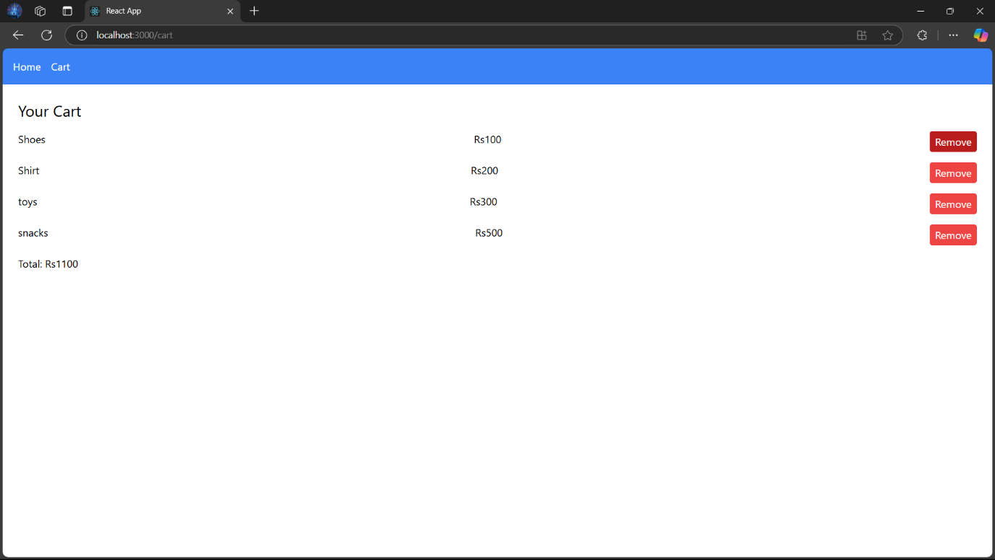
7. Once deleted, the cart will look like below with changed total price.